

This game is a strategy game entitled **LIFESAVER**. This game is about two friends; friend1 (player) is the one tasked to save friend2 (the other friend who got drowned). The player has 3 lives, his life decreases when he missed a lifesaver or he collected stones. It can be retrieved by collecting life jackets.

**History**

Why did I choose to make this kind of game?

I am afraid to swim. I am afraid to get drowned. During my college days, in our swimming class, I got drowned three (3) times and our lifeguard saved me. From then on, I idolized those lifeguards who save lives. That is also the reason why I made a game for them.

**Purpose**

The purpose of this game is to develop or enhance the thinking skills and to entertain people who will play this. This is a fun and interactive way of playing game.

**What it does**

As what I have said, the objective of this game is to save the drowned friend by collecting lifesavers (lifebuoys) flowing from the slide. Each collected lifesaver is equivalent to one step up of friend2. This game requires collecting three (3) lifesavers to obtain a big lifesaver. This big lifesaver will be thrown to friend2 in order for him to be saved.

This game has different level of difficulty. Each level consists of different backgrounds (Philippine beaches, Philippine rivers, Philippine resorts, etc.) or settings and in each level, lifesavers to be collected can be upgraded. For example, a lifebuoy which can save 1 person can be upgraded to a rubber boat which can save 2 persons, and so on. As the level increases, drowned friends increases meaning, more lifesavers to collect.

This game will be scored based on the number of collected lifesavers and friends

saved.

**Technologies Used**

* adt-bundle-windows-x86-20130219
* Adobe Photoshop
* Android Phone
* Adobe Flash

**Sample Graphics**

The following are some of the objects I will be using:

**Characters:**



**Player1 (lifeguard)** – He will act as the rescuer of the drowned friend.



**Drowned friend** – He got drowned and needs his friend’s help.

**Falling Objects from the slide:**



**Lifebuoy** – The player should collect or catch the prescribed number of lifebuoys for each level. If he/she missed one (1), he/she will lose a life.



**Life jacket** – If the player collected a life jacket, his/her life will be incremented by one.

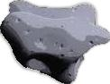

**Stone** – If the player accidentally collected this, he/she will lose a life.

**Logo**



This will be the logo that I will use.

**Wallpapers**



**Figure 1** **Figure 2** **Figure 3**

Like **Figure 1**, I am going to use Philippine resorts, beaches, rivers, etc. for my backgrounds.

**Figure 2**, is my Main screen. This will appear the moment the user clicked the icon.

I will use **Figure 3**, temporarily as my slide. It is supposed to be a flash file.

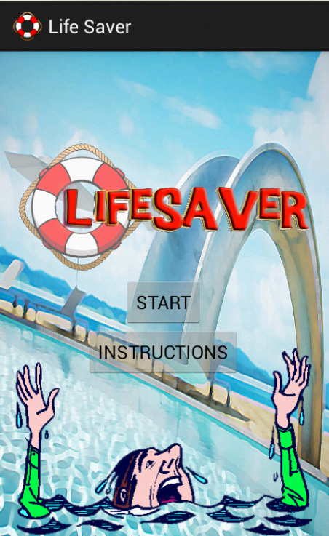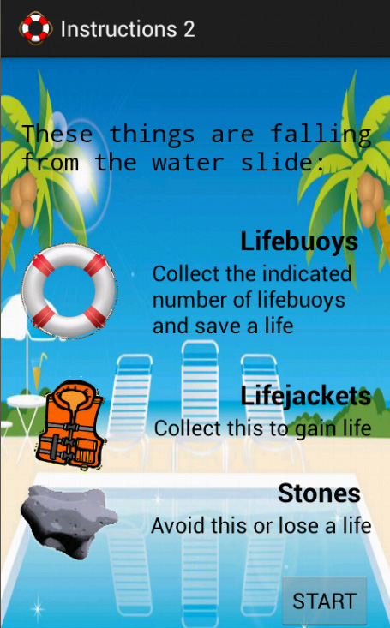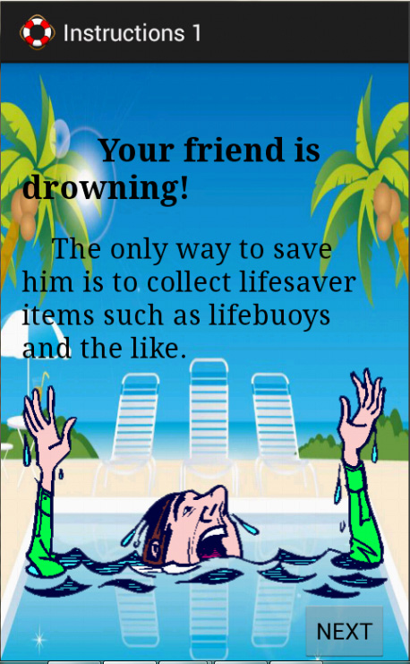

**MIND MAP (User’s Manual)**

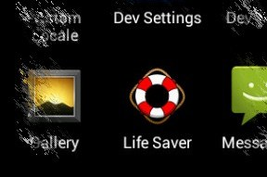**How to use LifeSaver**

1. Install LifeSaver.apk on your android phones.
2. Run the application.



1. On the menu screen, you will see two buttons; the start button and the instructions button.

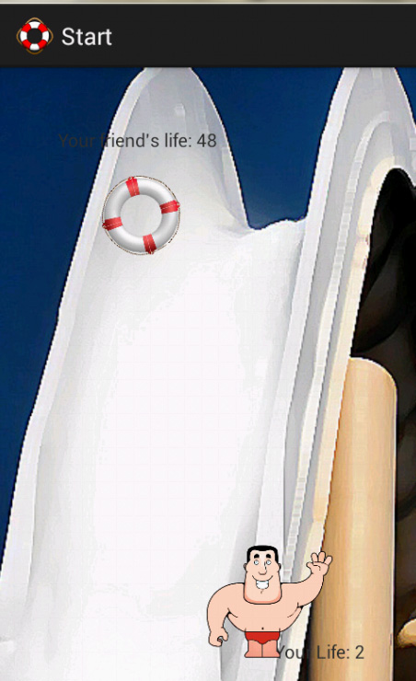

1. When you click the START button,

this start screen will appear:

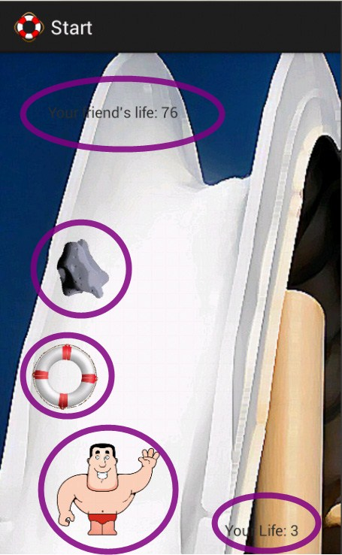

PLAYER (you). Move the player by touching the screen left to right and vice versa.

LIFEBUOY. Collect this and increase your friend’s life by 10.

STONE. If you collected this, your life will be decreased by 1 and your friend’s life, by 2.

This indicates your friend’s life. Since your friend is drowned, his life will start at 50. He will be saved if it turned 100 and will be drowned if it turned zero.

‘

This is your life indicator. It starts with 3 and will increase or decrease depending on the item that you collected. Make it zero and the game will be over.

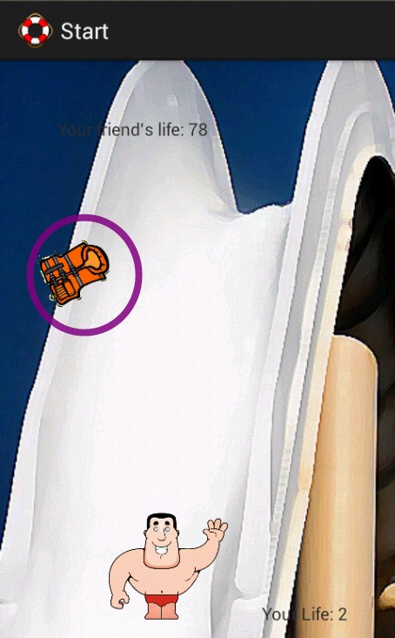

LIFE JACKETS. Collect this and your life will increase by 1.

1. When you click the Instructions button, this will appear:

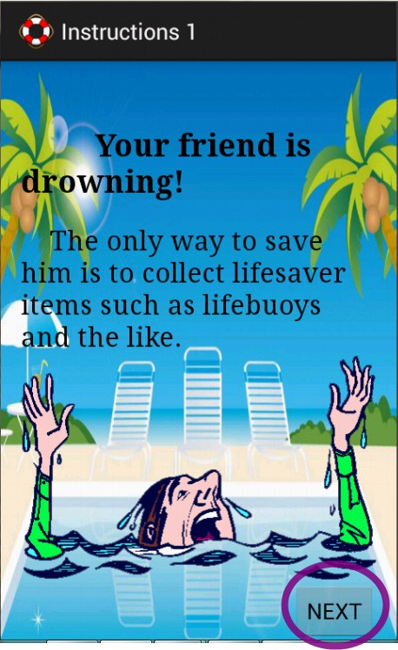Click NEXT and this will appear:

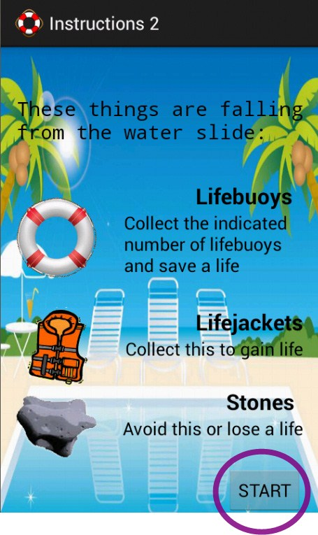

1. Click START to start playing the game.
2. When your life turned to zero, this will appear:

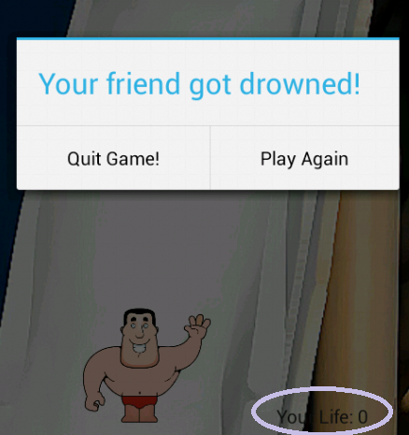

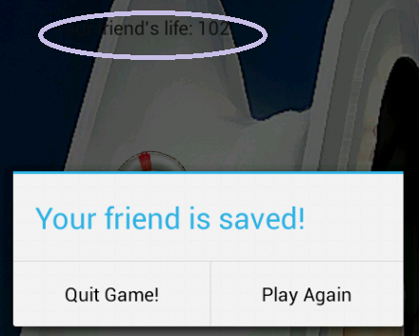When your friend’s life turned 100 and above, this will appear:

**Target Users**

Kids, teenagers and adults can play this game. It is a strategy game so; it requires good thinking skills and fast hands.

**How do you intend to monetize your application?**

* If the player enjoyed playing my game, I think he/she will be encouraged to upgrade the boosters and add some power ups.

**How much would your app cost?**

* I will make my application downloaded for free since it’s for fun and they can upgrade their boosters and power-ups.

**References:**

* **Images:** 
  + <http://cloud.graphicleftovers.com/12009/355944/lifeguard-waving.jpg>
  + <http://t2.gstatic.com/images?q=tbn:ANd9GcQN5r6B6pmEI_fsBAvH_nSt60rc6vHzk>B  [CJCpVWyRD7d-lB8Rn](http://t2.gstatic.com/images?q=tbn:ANd9GcQN5r6B6pmEI_fsBAvH_nSt60rc6vHzkBCJCpVWyRD7d-lB8Rnu)u
  + <http://t0.gstatic.com/images?q=tbn:ANd9GcR0GfRCruzjiHJgHytF4YY6g-Ns9Ts>- [olnjbNHsKwJpJWlYCu3j_](http://t0.gstatic.com/images?q=tbn:ANd9GcR0GfRCruzjiHJgHytF4YY6g-Ns9Ts-olnjbNHsKwJpJWlYCu3j_Q)Q
  + <http://t0.gstatic.com/images?q=tbn:ANd9GcQAcADgIiFmu>- [KcJHVJ9NbDBGHKoxkXU_Z5YIhLOjVCnAyWIpH](http://t0.gstatic.com/images?q=tbn:ANd9GcQAcADgIiFmu-KcJHVJ9NbDBGHKoxkXU_Z5YIhLOjVCnAyWIpHa)a
  + [http://1.bp.blogspot.com/](http://1.bp.blogspot.com/-kQHch29xtzY/T7LeKObQHiI/AAAAAAACS4A/31t83Rq6Qtc/s1600/Shoot%2Bslide%2B6iihih.jpg)- [kQHch29xtzY/T7LeKObQHiI/AAAAAAACS4A/31t83Rq6Qtc/s1600/Shoot%2Bslide%2](http://1.bp.blogspot.com/-kQHch29xtzY/T7LeKObQHiI/AAAAAAACS4A/31t83Rq6Qtc/s1600/Shoot%2Bslide%2B6iihih.jpg)B  [6iihih.jp](http://1.bp.blogspot.com/-kQHch29xtzY/T7LeKObQHiI/AAAAAAACS4A/31t83Rq6Qtc/s1600/Shoot%2Bslide%2B6iihih.jpg)g
* **Other sources:** 
  + [http://www.javacodegeeks.com/2012/10/android-leaf-fall-like-animation](http://www.javacodegeeks.com/2012/10/android-leaf-fall-like-animation-using.html)- [using.htm](http://www.javacodegeeks.com/2012/10/android-leaf-fall-like-animation-using.html)l
  + <http://mobile.tutsplus.com/tutorials/android/getting-started-with-renderscript-on>- [android](http://mobile.tutsplus.com/tutorials/android/getting-started-with-renderscript-on-android/)/
  + <http://www.warriorpoint.com/blog/2009/05/29/android-switching-screens-by>- [dragging-over-the-touch-screen](http://www.warriorpoint.com/blog/2009/05/29/android-switching-screens-by-dragging-over-the-touch-screen/)/
  + [http://developer.android.com/tools/device.htm](http://developer.android.com/tools/device.html)l